# Teradata: Create Stored Procedure & Invoke from Python

Change the Session Character Set and Driver Options on the ODBC Driver as follows:

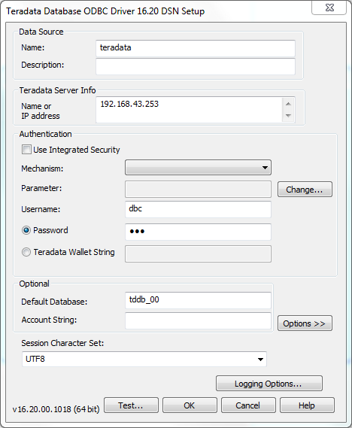

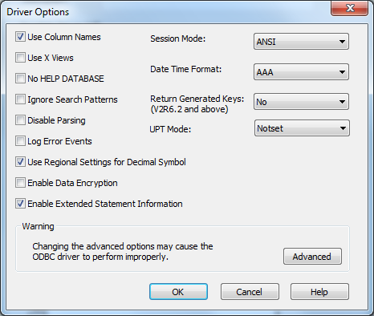

Create a table to log data:

--DROP TABLE - If the table needs to be recreated

--DROP TABLE tddb_00.Weather_Log;

--CREATE TABLE

**CREATE** **TABLE** tddb_00.Weather_Log

(Log_Id **INT** **NOT** **NULL** **GENERATED** **ALWAYS** **AS** **IDENTITY**

(**START** **WITH** 1

**INCREMENT** **BY** 1

**MINVALUE** 1

**MAXVALUE** 2147483647

**NO** **CYCLE**),

Date_Time **TIMESTAMP**,

Temperature **FLOAT**,

Humidity **FLOAT**,

Image_Blob **VARCHAR**(100),

Cloud_Type **VARCHAR**(50)

)

**UNIQUE** **PRIMARY** **INDEX**(Log_Id);

Run this once:

--GRANT PROCEDURE PERMISSIONS

**GRANT** **CREATE** **PROCEDURE** **ON** "tddb_00" **TO** "DBC" **WITH** **GRANT** **OPTION**;

Create the stored procedure:

--CREATE PROCEDURE TO LOG DATA

**CREATE** **PROCEDURE** tddb_00.Weather_Log_Create(

**IN** iTemperature **FLOAT**,

**IN** iHumidity **FLOAT**

)

**BEGIN**

**INSERT** **INTO** tddb_00.Weather_Log

(

Date_Time

, Temperature

, Humidity

, Image_Blob

, Cloud_Type

)

**VALUES**

(

**CURRENT_TIMESTAMP** **AT** **TIME** **ZONE** 'Africa Egypt'

, iTemperature

, iHumidity

, **NULL**

, **NULL**

);

**END**;

Test the stored procedure:

--CALL PROCEDURE

**CALL** tddb_00.Weather_Log_Create(1, 1);;

--SELECT FROM TABLE

**SELECT** *

**FROM** tddb_00.Weather_Log

**ORDER** **BY** Log_Id **DESC**;